**GURU GHASIDAS VISHWAVIDYALAYA, BILASPUR (C.G.)**



**DECLARATION**

I hereby declare that the project entitled “**EatIt : Food Ordering Android Application”** submitted to the department of Computer Science & Information Technology, GURU GHASIDAS VISHWAVIDYALAYA BILASPUR (C.G.) affiliated to the partial fulfillment of the requirement for the award of Master of Computer Application (MCA) is a result of original work carried out by me. This work is original has not been submitted so for in part or full for any other university or institute*.*

Date-22/11/2019 DEVESH SAHU

ROLL NO:-17606244

**GURU GHASIDAS VISHWAVIDYALAYA, BILASPUR (C.G.)**



**CERTIFICATE OF APPROVAL**

This is to certify that the project entitled **“EatIt : Food Ordering Android Application”** carried out by **“Devesh Sahu”**, a student of 5th semesters Master of Computer Application (MCA) at GURU GHASIDAS CENTRAL UNIVERSITY, BILASPUR (C. G.). Is here by approved after proper examination and evaluation as a creditable work for the partial fulfillment of the requirement for awarding the degree of Master of Computer Application (MCA) at GURU GHASIDAS CENTRAL UNIVERSITY (C.G).

**(Internal Examiner) (External Examiner)**

**Date:22/11/2019**

**GURU GHASIDAS VISHWAVIDYALAYA, BILASPUR (C.G.)**



**CERTIFICATE BY GUIDE**

This is to certify that **Devesh Sahu** bearing Enrollment No. – GGV/14/7128 has developed software project titled “**EatIt : Food Ordering Android Application”** for GURU GHASIDAS VISHWAVIDYALAYA as partial fulfillment for the award of the degree of Master of Computer Application (MCA).

**Date: 22/11/2019 GUIDED BY**

**Place:-BILASPUR Dr. Rajwant Rao**

**Asst. Prof. CSIT**

**GURU GHASIDAS VISHWAVIDYALAYA, BILASPUR (C.G.)**



**FORWARDING CERTIFICATE BY**

**HEAD OF DEPARTMENT**

This is to certify that DEVESH SAHU is a student of Master of Computer Application (MCA) at GURU GHASIDAS VISHWAVIDYALAYA, BILASPUR (C. G.), has carried out the project work as mentioned in this report entitled **“EatIt : Food Ordering Android Application”** during his 5th semester of studies in Master of Computer Application (MCA) as a part of the curriculum for obtaining the degree of MCA from the GGV, BILASPUR (C.G) to which the Institute is affiliated. This certificate issued by the undersigned does not cover any responsibility regarding the statements made and work carried out by the concerned student. The current dissertation is hereby being forwarded for evaluation for the purpose for which it has been submitted.

Date:22/11/2019 **Head of Department**

Dr. Rajwant Rao Mrs. P. PUJARI

Asst. Prof. CSIT HOD CSIT

**ACKNOWLEDGEMENT**

**“Encouragement and revealing suggestion is a constant source of inspiration.”**

I have great pleasure in the submission of this project report entitled “**EatIt Android App**” in partial fulfillment of Master of Computer Application (MCA).

While submitting this project report, I take this opportunity to thank those, directly or indirectly related to project work. Without their active co-operation and guidance, it would have become very difficult to complete this task in times.

I would like to express sincere thanks and gratitude to Mrs. P. PUJARI (Head of Department, CSIT) and staffs of GURU GHASIDAS CENTRAL UNIVERSITY (C.G.) for their continuous help and guidance throughout the course of project.

While submission of this project, I also like to thanks my project guide who gave me guidance right from the initial stage of project and offered me several valuable suggestions.

**CONTENTS**

**1.Objective………………………………………………………………………………………………..8**

**2.Introduction……………………………………………………………………………………………9**

**3.Existing & Proposed System…………………………………………………………………10-11**

**4.Requirement Analysis………………………………………………………………………….12-13**

**5.Feasibility Analysis…………………………………………………………………………………14**

**6.System design……………………………………………………………………………………..15-18**

**7.Introduction to Languages…………………………………………………………………..19-28**

**8.Data Flow Diagram………………………………………………………………………………29-33**

**9.Screenshots…………………………………………………………………………………………34-45**

**10.Conclusion…………………………………………………………………………………………..46**

**11.Future Aspects…………………………………………………………………….................47**

**12.Bibliography..........................................................................................48**

**1. OBJECTIVE**

* The purpose of online food and Tiffin ordering applications is to automate the existing physical structure by the help of automated apparatus and full-fledged computer software, satisfying their requirements, so that their appreciated data/information can be deposited for a longer stage with easy retrieving and guidance of the identical.
* This investigation work goals to automate the food ordering process in near neighborhood and also improve the dining understanding of customers.
* This system, implements wireless data entrance to server.
* The android application on user’s mobile will have all the menu specifics. The order details from customer’s mobile are wirelessly rationalized in central database and consequently send to kitchen and cashier correspondingly.

**2. INTRODUCTION**

The “**EatIt : Food Ordering Android Application**” has been residential to countermand the problems customary in the practicing handbook system. A location-based service (LBS) is a mobile application that is dependent on the location of a mobile device, like mobile phone. This software is supported to eradicate and in some cases diminish the adversity faced by this breathing system. Moreover this system is designed for exacting need of the company to carry out operations in a smooth and effective manner. The Food Ordering Android Application is the Android Application for customized Food ordering. User will be capable to get delivery on his present location by GPS description. Delivery tracking, food production process suggestion, share enduring food, plunder and many more description are there in Food Ordering Android Application. The application is condensed as much as potential to avoid errors while incoming the data. It also provides error message while incoming unsound data. No formal facts is needed for the user to use this system. Thus by this all it provides it is intelligible. Food Ordering Android Application, as described above, can lead to mistake free, protected, reliable and fast administration system. It can help the user to deliberate on their other performance rather to deliberate on the record maintenance.

**3. EXISTING AND PROPOSED SYSTEM**

**3.1 Existing System**

In an existing system for giving any orders, a user should visit Hotels or Restaurants to know about food items and then give orders and pay in advance or you need to select menu and place an order on call. In this method time and manual work is required. Maintaining critical information in the files and manuals is full of risk and tedious process.

Tracking of Delivery is not available in previous applications and Booking of a particular table in advance is also not available. Customization of Order, Current status of the order is not available. Some systems contain an outdated database that is Restaurant is closed, yet it shows on the application.

**3.1.1 Drawbacks of Existing System**

1) Do not take mass order.

2) Does not indicate the famous dishes of a particular restaurant.

3) Nobody shows the current status of delivery.

4) Mismatch in delivery expected time.

5) Outdated data.

**3.2 Proposed system**

The application is an online food ordering system which consists of GPS option where the application user can select the option to see the restaurants nearby his vicinity. It is mainly implemented using Global Positioning System (GPS).Users with location-aware wireless devices can query about their surroundings at any place, anytime. This android application enables the end users to register on the application, select the food from menu card and order food by an android app. The User will receive a confirmation call, by selecting and ordering the food they want to have. The results after selecting food from menu card will directly appear in web application part on the system of a manager. By using this application the work of waiter is reduced or we can say that work is nullified. The benefit is that if there is a rush in a restaurant then there will be chances that the waiters will be unavailable and then the users can directly order the food by using android application. The user is given Username and Password to Login.

The User can see the list of Restaurants on the basis of the User Ratings given. The user can see the different cuisines offered at the restaurants and the related food menus along with their prices. The User can place the order accordingly and after the order is placed a confirmation mail is sent to the user. Then the bill is generated which has the order price and according to the user location, the delivery charges are calculated. Another module will be consisting of a Manager application where the hotel staff can log in and can update/change the menu and prices accordingly. For every order placed through the application, we have assumed that our portal gets a 20% of royalty.

**3.2.1 Advantages of proposed system**

1. Tracking of orders.

2. One step registration with android application.

3. Instant notification of the order, when the order is confirmed, dispatched and delivered.

4. Advance ordering.

5. Customize food ordering.

6. Various secured payment methods.

7. Subscription-based registration of hotels, restaurant, and vendors.

8. Ability to order food from nearby restaurants and hotels.

9. Provision of restaurant owners to register themselves with their menus.

10. With the GPS, easy searching of nearby restaurants and hotels.

11. Tiffin services.

12. Table booking.

13. Leftover food is given to NGO.

**3.2.2 Disadvantages of proposed system**

1. Once an order has been dispatched, it cannot be cancelled.

2. Availability of internet to use application.

**4. REQUIREMENT ANALYSIS**

“*Necessity is the mother of invention*” the said phrase is totally true. If we don’t need any thing we don’t go for it or discover it. Similar is the case with this project also. It is always very good to have a product which is very much efficient, easy to handle, cost effective, easy to maintain and error less. As we all know to organize a database for any student record in any school or college demands a lot of effort time and money, if we want to organize it once again, the same amount of resources will be required once again.

This project is the solution to avoid above mentioned problem. Once this project is installed it will work for life time, with no extra expenditure or human effort, hence it will save money and man power, also the performance will be more satisfactory as compare to manual work because it is error less and more reliable. Also it requires very less maintenance.

**4.1 SYSTEM REQUIREMENT**

**4.1.1 HARDWARE REQUIREMENT FOR DEVELOPMENT:**

* 1.8 GHz Processors and above
* RAM 4 GB and above
* HDD 40 GB hard disk space and above
* An Android Smartphone with Android OS lollipop or higher.

**4.1.2 SOFTWARE REQUIREMENT :**

* WINDOWS OS( xp and above), Linux, Mac OS.
* Any Browser for accessing Firebase & some Google and other APIs.
* Android Studio Latest Version with latest SDK tools.
* SQLite DB Browser.
* ARC tool & AVD(android virtual device) for testing.

**4.2 Software Requirement Specification:**

* SDLC is a process which we are following to complete software project that include both development as for testing, for completion of every activity in this world require one process.
* This document play a vital role in the development of life cycle (SDLC) as it describes the complete requirement of the system.
* It means for use by developers and will be the basic during testing phase. Any changes made to the requirements in the future will have to go through formal change approval process.

**5. FEASIBILITY ANALYSIS**

An important outcome or the preliminary investigation of the system requested is feasible. There are three aspects of feasibility study portion of the preliminary investigation.

**5.1 Economical Feasibility:**

The proposed system is economical feasible. There is no much difference in the expenditure, it will save a lot of paper work hence stationery will be saved and also there is no need of so many operators to operate this.

**5.2 Technical Feasibility:**

The proposed system is technically feasible. There is no need of costly and advanced system. This new system requires at least Microsoft Windows XP with DOS and it need Intel I3 or higher processor with minimum 4GB RAM. There is no need of special education and training to the users.

**6. SYSTEM DESIGN**

System design is a critical part of any system whose requirements are translated into a representation of software. Once software designing is complete it is coded and tested later. System design is conducted in the following steps.

1. Data design

2. Architectural design

3. Procedural design

4. Interface design

5. Use-Case Diagram

**6.1 Preliminary design:**

Preliminary design is concerned with the transformation of requirements of data and software architecture. While designing top-down approach is followed and the system is broken into smaller modules. Each module is smaller and independent of other modules and is aimed in improving system and coupling.

Preliminary design is nothing but data and architectural design. The data design transfers information domain created during requirement analysis into data structure that will be required to implement the software. For proper identifying information flow, from input is processing till the output is obtained. For all these a graphical representation is used.

**6.2 Data Design:**

Data Design transforms the information domain model created during requirement analysis into data structure that will be required implementing the software.

Graphical representation like data flow diagram can be used to identify all the data flow through the steps of input, processing until the output is given.

Data flow diagram is graphical representation of data flow, process and files used in support of an information system. In other words, it is the way of expressing system requirements in graphical form. It is used to clarifying system requirements and identifying major problems in system design.

Data flow diagram models a system by using external form which data flows to a process, which transforms the data and create optional data, go to the process or external entities or files. Data in fields may also flow to other processes and input. The merit of DFD is that it precede an overview of what data system should have, what transformations redone, what files are used and where the results flow.

The procedure followed while drawing DFD of a system is to first identify the major entities and process in the system, files used by the system without explaining the processes.

Later the processes used in the system should be identified but refining the context level diagram, context level diagrams are further exploded in first level DFDs where main processes and important data files used in transaction and data flow between them is represented.

In the second level DFD, the sub process of the same process and concerned and data flow between them are represented. Data dictionary stores descriptions of data items and structure as well as system processes. It is intended to be understand the system by analyst, how retrieve the details and descriptions it stores, and during system design, when information about such concern as data length, alternate names, and data used in specific processes much available. The data dictionary stores validation information to guide the analyst in specifying controls for systems acceptance of guide.

**6.3 Architectural design:**

The software architecture of a program or computer system is the structure of the system which comprises system elements, the externally visible properties of those elements, and relationship among them.

“Externally visible” properties refers to those assumptions other elements can make of an element, such as its provided services, performance characteristics, fault handling, shared resource usage and so on.

We have tried to keep the architecture as simple as possible; it is a linear system, flow of data is simple.

**6.4 Procedural design:**

The Procedural design describes structured programming concepts using graphical, tabular, and textual notations. These design mediums enable the designer to represent procedural detail that facilitates translation to code. This blueprint for implementation forms the basis for all subsequent software engineering work.

Our system is fully procedural and modular it is divided into small-small procedures using function and member of those function are being used to access the functionality of the system, in this way our project becomes extendable we can enhance any part without affecting the rest.

**6.5 Interface design:**

Now days it is considered or thought of user interface as interfaces that are at least screen-oriented, limited to drawing simple alphabetic characters in fixed rows and columns. A Graphical User Interface is one that controls a bit –mapped graphics display device.

GUI is about creating a medium through which a user- most likely a Human- can effectively communicate with the underlying program logic and affect its state and behavior. The user must be able to understand the interface, its functions, its messages, and its logical flow.

Two main points to consider in designing…

1. The GUI interface should clearly convey the proper perspective and level of detail appropriate for the background of the target.
2. The design should first and foremost support an interface that creates the most meaningful abstraction, and organizes functions, data and workflow in the most intuitive for the user.

**7. Introduction to Languages**

**7.1 Introduction of Java**

Java is a popular programming language, created in 1995. It is owned by Oracle, and more than **3 billion** devices run Java.

It is used for:

* Mobile applications (specially Android apps)
* Desktop applications
* Web applications
* Web servers and application servers
* Games
* Database connection

## **7.1.1 Why Use Java?**

* Java works on different platforms (Windows, Mac, Linux, Raspberry Pi, etc.)
* It is one of the most popular programming language in the world
* It is easy to learn and simple to use
* It is open-source and free
* It is secure, fast and powerful
* It has a huge community support (tens of millions of developers)
* As Java is close to [C++](https://www.w3schools.com/cpp/default.asp) and [C#](https://www.w3schools.com/cs/default.asp), it makes it easy for programmers to switch to Java or vice versa

**7.1.2 Features of Java**

The main goal was to design a language that could offer solutions to problems encountered in modern programming. The goal was for the language to be reliable, portable, and distributed, and at the same time, it needed to be simple, compact, and interactive.

### **Compiled and Interpreted**

Java language combines both of these approaches, thus making Java a two-stage system. This approach was never offered before, as any language before was either compiled or interpreted.

**Independent and Portable**

Java programs can be easily moved from one system to another, anywhere and anytime. With changes or an upgrade in the operating system, processors and system resources will not force any changes in Java programs.

**Object-Oriented**

Almost everything in Java language is an object, which makes it a true object-oriented language. All program code and data reside within objects and classes. Java comes with an extensive set of classes that are arranged in packages, which can be used in program inheritance.

### **Robust and Secure**

Java provides many safeguards to ensure reliable code. It has strict run-time, checking for data types. It is designed like a garbage collected language, i.e., it captures series errors and eliminates any risk of crashing the system.

Java systems verify all the memory access and, thus, ensure that no virus is communicated with an applet.

### **Distributed**

Java programming facilitates both the sharing of data and programs. Java applications can open and access remote objects on the Internet as easily as on any local system.

### **Simple, Small, and Familiar**

Java is a simplified version of C++, which is why it is familiar and yet different as it eliminates all the redundant and unreliable code

### **Multithreaded and Interactive**

Multithreaded means handling different tasks simultaneously. Java language supports multithreaded programs, which means that we need not have to wait for one task to finish for another to start.

### **High Performance**

Java programming performance is very impressive, considering the fact that is an interpreted language, mainly because of the bytecodes. Java architecture is designed to reduce overheads.

### **Dynamic and Extensible**

Java is a dynamic language; it is capable of dynamically linking in new class libraries, methods, and objects. It can also determine the type of class through a query.

### **Ease of Development**

Java 2 standard edition (J2SE) 5.0 supports features such as Generics, Enhanced [**for loop**](https://data-flair.training/blogs/loops-in-java/), Autoboxing or unboxing, Typesafe enums, varargs, Static import, and Annotation.

**7.2 Introduction to Android**

Android is a Linux based operating system it is designed primarily for touch screen mobile devices such as smart phones and tablet computers. The operating system have developed a lot in last 15 years starting from black and white phones to recent smart phones or mini computers. One of the most widely used mobile OS   these days is android.  The android is software that was founded in Palo Alto of California in 2003.

The android is a powerful operating system and it supports large number of applications in Smartphones. These applications are more comfortable and advanced for the users. The hardware that supports android software is based on ARM architecture platform. The android is an open source operating system means that it’s free and any one can use it. The android has got millions of apps available that can help you managing your life one or other way and it is available low cost in market at that reasons android is very popular.

### **7.2.1 Android Architecture:**

The android is a operating system and is a stack of software components which is divided into five sections and four main layers that is

* Linux kernel
* Libraries
* Android runtime

### **Linux kernel:**

The android uses the powerful Linux kernel and it supports wide range of hardware drivers. The kernel is the heart of the operating system that manages input and output requests from software. This provides basic system functionalities like process management, memory management, device management like camera, keypad, display etc the kernel handles all the things. The Linux is really good at networking and it is not necessary to interface it to the peripheral hardware. The kernel itself does not interact directly with the user but rather interacts with the shell and other programs as well as with the hard ware devices on the system.

### **Libraries:**

The on top of a Linux kennel there is a set of libraries including open source web browser such as webkit, library libc. These libraries are used to play and record audio and video. The SQLite is a data base which is useful for storage and sharing of application data. The SSL libraries are responsible for internet security etc.

### **Android Runtime:**

The android runtime provides a key component called Dalvik Virtual Machine which is a kind of java virtual machine. It is specially designed and optimized for android. The Dalvik VM is the process virtual machine in the android operating system. It is a software that runs apps on android devices

### Android Architecture**7.2.2 Application frame work**

**7.3 Introduction to Firebase**

## A brief post about what Firebase is all about, and it’s new NoSQL Database — Cloud Firestore

With a variety of server-side technologies that are on the market today, developers have a tough job of deciding what kind of backend is most suitable for their app.

In this post, we will explore one of these choices that goes by the name of Firebase 🔥, and all the tools and services that it provides.

### https://hackernoon.com/hn-images/1*t3Eh571oT4I37kOCWD6tuQ.png[Firebase](http://firebase.google.com/official/site‎)

Firebase is a mobile and web app development platform that provides developers with a plethora of tools and services to help them develop high-quality apps, grow their user base, and earn more profit.

#### **Firebase Services**

Firebase Services can be divided into two groups:

Develop & test your app

* [**Realtime Database**](https://firebase.google.com/docs/database/)
* [**Auth**](https://firebase.google.com/docs/auth/)
* [**Test Lab**](https://firebase.google.com/docs/test-lab/)
* [**Crashlytics**](https://firebase.google.com/docs/crashlytics/)
* [**Cloud Functions**](https://firebase.google.com/docs/functions/)
* [**Firestore**](https://firebase.google.com/docs/firestore/)
* [**Cloud Storage**](https://firebase.google.com/docs/storage/)
* [**Performance Monitoring**](https://firebase.google.com/docs/perf-mon/)
* **Crash Reporting**
* 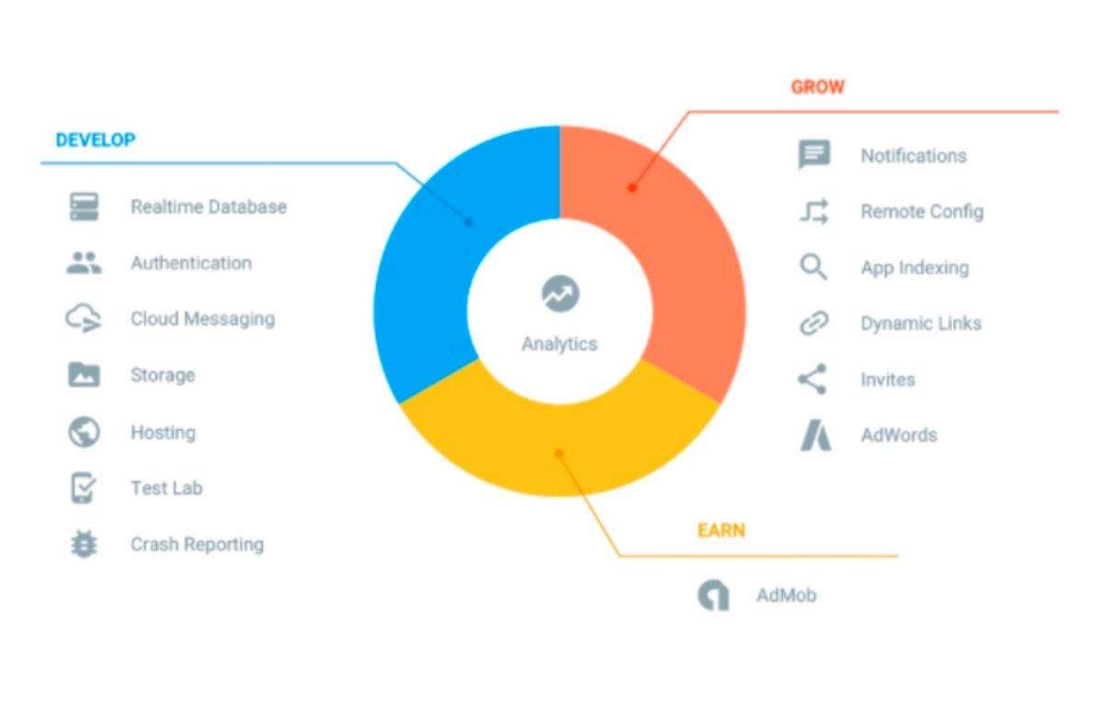[**Hosting**](https://firebase.google.com/docs/hosting/)

Grow & Engage your audience

* [**Firebase Analytics**](https://firebase.google.com/docs/analytics/)
* [**Invites**](https://firebase.google.com/docs/invites/)
* [**Cloud Messaging**](https://firebase.google.com/docs/cloud-messaging/)
* [**Predictions**](https://firebase.google.com/docs/predictions/)
* [**AdMob**](https://firebase.google.com/docs/admob/)
* [**Dynamic Links**](https://firebase.google.com/docs/dynamic-links/)
* [**Adwords**](https://firebase.google.com/docs/adwords/)
* [**Remote Config**](https://firebase.google.com/docs/remote-config/)
* [**App Indexing**](https://firebase.google.com/docs/app-indexing/)
  1. **Introduction to XML**

XML stands for **E**xtensible **M**arkup **L**anguage. It is a text-based markup language derived from Standard Generalized Markup Language (SGML).

XML tags identify the data and are used to store and organize the data, rather than specifying how to display it like HTML tags, which are used to display the data. XML is not going to replace HTML in the near future, but it introduces new possibilities by adopting many successful features of HTML.

There are three important characteristics of XML that make it useful in a variety of systems and solutions −

* **XML is extensible** − XML allows you to create your own self-descriptive tags, or language, that suits your application.
* **XML carries the data, does not present it** − XML allows you to store the data irrespective of how it will be presented.
* **XML is a public standard** − XML was developed by an organization called the World Wide Web Consortium (W3C) and is available as an open standard.

## **XML Usage**

A short list of XML usage says it all −

* XML can work behind the scene to simplify the creation of HTML documents for large web sites.
* XML can be used to exchange the information between organizations and systems.
* XML can be used for offloading and reloading of databases.
* XML can be used to store and arrange the data, which can customize your data handling needs.
* XML can easily be merged with style sheets to create almost any desired output.
* Virtually, any type of data can be expressed as an XML document.

## **What is Markup?**

XML is a markup language that defines set of rules for encoding documents in a format that is both human-readable and machine-readable. So *what exactly is a markup language?* Markup is information added to a document that enhances its meaning in certain ways, in that it identifies the parts and how they relate to each other. More specifically, a markup language is a set of symbols that can be placed in the text of a document to demarcate and label the parts of that document.

Following example shows how XML markup looks, when embedded in a piece of text −

<message>

<text>Hello, world!</text>

</message>

This snippet includes the markup symbols, or the tags such as <message>...</message> and <text>... </text>. The tags <message> and </message> mark the start and the end of the XML code fragment. The tags <text> and </text> surround the text Hello, world!.

## **Is XML a Programming Language?**

A programming language consists of grammar rules and its own vocabulary which is used to create computer programs. These programs instruct the computer to perform specific tasks. XML does not qualify to be a programming language as it does not perform any computation or algorithms. It is usually stored in a simple text file and is processed by special software that is capable of interpreting XML.

* 1. **Introduction to Json**

JSON or JavaScript Object Notation is a lightweight text-based open standard designed for human-readable data interchange. Conventions used by JSON are known to programmers, which include C, C++, Java, Python, Perl, etc.

* JSON stands for JavaScript Object Notation.
* The format was specified by Douglas Crockford.
* It was designed for human-readable data interchange.
* It has been extended from the JavaScript scripting language.
* The filename extension is **.json**.
* JSON Internet Media type is **application/json**.
* The Uniform Type Identifier is public.json.

## **Uses of JSON**

* It is used while writing JavaScript based applications that includes browser extensions and websites.
* JSON format is used for serializing and transmitting structured data over network connection.
* It is primarily used to transmit data between a server and web applications.
* Web services and APIs use JSON format to provide public data.
* It can be used with modern programming languages.

## **Characteristics of JSON**

* JSON is easy to read and write.
* It is a lightweight text-based interchange format.
* JSON is language independent.

## **Simple Example in JSON**

The following example shows how to use JSON to store information related to books based on their topic and edition.

{

"book": [

{

"id":"01",

"language": "Java",

"edition": "third",

"author": "Herbert Schildt"

},

{

"id":"07",

"language": "C++",

"edition": "second",

"author": "E.Balagurusamy"

}

]

}

* 1. **Introduction to SQLite Database**

SQLite is a software library that implements a self-contained, serverless, zero-configuration, transactional SQL database engine. SQLite is one of the fastest-growing database engines around, but that's growth in terms of popularity, not anything to do with its size. The source code for SQLite is in the public domain.

## **What is SQLite?**

SQLite is an in-process library that implements a self-contained, serverless, zero-configuration, transactional SQL database engine. It is a database, which is zero-configured, which means like other databases you do not need to configure it in your system.

SQLite engine is not a standalone process like other databases, you can link it statically or dynamically as per your requirement with your application. SQLite accesses its storage files directly.

## **Why SQLite?**

* SQLite does not require a separate server process or system to operate (serverless).
* SQLite comes with zero-configuration, which means no setup or administration needed.
* A complete SQLite database is stored in a single cross-platform disk file.
* SQLite is very small and light weight, less than 400KiB fully configured or less than 250KiB with optional features omitted.
* SQLite is self-contained, which means no external dependencies.
* SQLite transactions are fully ACID-compliant, allowing safe access from multiple processes or threads.
* SQLite supports most of the query language features found in SQL92 (SQL2) standard.
* SQLite is written in ANSI-C and provides simple and easy-to-use API.
* SQLite is available on UNIX (Linux, Mac OS-X, Android, iOS) and Windows (Win32, WinCE, WinRT).

**8. Data Flow Diagram**

A data flow diagram is graphical tool used to describe and analyze movement of data through a system. These are the central tool and the basis from which the other components are developed. The transformation of data from input to output, through processed, may be described logically and independently of physical components associated with the system. These are known as the logical data flow diagrams. The physical data flow diagrams show the actual implements and movement of data between people, departments and workstations. A full description of a system actually consists of a set of data flow diagrams. Using two familiar notations Yourdon, Game and Samson notation develops the data flow diagrams. Each component in a DFD is labeled with a descriptive name. Process is further identified with a number that will be used for identification purpose. The development of DFD’S is done in several levels. Each process in lower level diagrams can be broken down into a more detailed DFD in the next level. The lop-level diagram is often called context diagram. It consists a single process bit, which plays vital role in studying the current system. The process in the context level diagram is exploded into other process at the first level DFD.

The idea behind the explosion of a process into more process is that understanding at one level of detail is exploded into greater detail at the next level. This is done until further explosion is necessary and an adequate amount of detail is described for analyst to understand the process.

Larry Constantine first developed the DFD as a way of expressing system requirements in a graphical from, this lead to the modular design.

A DFD is also known as a “bubble Chart” has the purpose of clarifying system requirements and identifying major transformations that will become programs in system design. So it is the starting point of the design to the lowest level of detail. A DFD consists of a series of bubbles joined by data flows in the system.

**8.1 DFD SYMBOLS:**

In the DFD, there are four symbols

1. A square defines a source(originator) or destination of system data
2. An arrow identifies data flow. It is the pipeline through which the information flows
3. A circle or a bubble represents a process that transforms incoming data flow into outgoing data flows.
4. An open rectangle is a data store, data at rest or a temporary repository of data

Process that transforms data flow.

Source or Destination of data

Data flow

Data Store

**8.2 DATA FLOW**

1) A Data Flow has only one direction of flow between symbols. It may flow in both directions between a process and a data store to show a read before an update. The later is usually indicated however by two separate arrows since these happen at different type.

1. A join in DFD means that exactly the same data comes from any of two or more different processes data store or sink to a common location.
2. A data flow cannot go directly back to the same process it leads. There must be at least one other process that handles the data flow produce some other data flow returns the original data into the beginning process.

**Chapter – 4**

**Data Flow Diagram**

1. A Data flow to a data store means update (delete or change).
2. A data Flow from a data store means retrieve or use.

A data flow has a noun phrase label more than one data flow noun phrase can appear on a single arrow as long as all of the flows on the same arrow move together as one package.

**8.3 DATA FLOW DIAGRAM:**

**8.3.1 Client App**

**8.3.1.1 Welcome Activity**

Welcome Activity

Sign Up

Sign In

Add data to firebase database

Verify the data and login

Home Activity

**8.3.1.2 Home Activity**

Home Activity

Click Menu Item or Banner Item

Comment Activity

Sub-category activity

Cart Activity

Add to cart or give review or comment

**8.3.1.3 Cart Activity**

Cart Activity

Place order

Payment Gateway & processing order

Order Dialog box

Home Activity

**8.3.2 Server App**

**8.3.2.1 Welcome Activity**

Welcome Activity

Verify the data and login

Home Activity

**8.3.2.2 Add, Modify & Delete**

Sub-category Activity

Home Activity

Click Items

Banner Activity

Category Activity

Add Modify & Delete in firebase database

Current Activity

**8.3.2.3 Order Management**

Order Activity

Click Items

Remove

Details

Details

Status

Current Activity

**9.SCREENSHOTS**

**9.1 Welcome Activity 9.2 Sign Up**

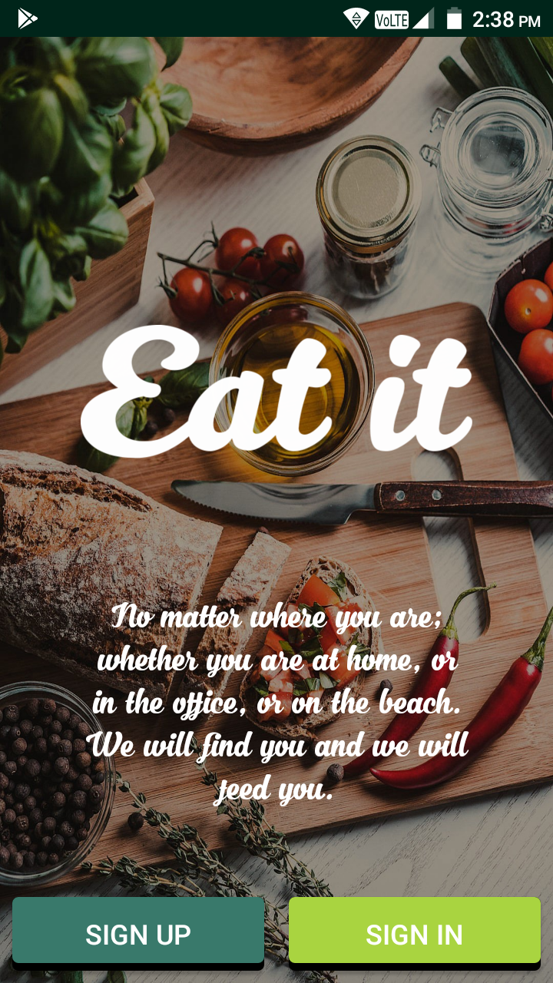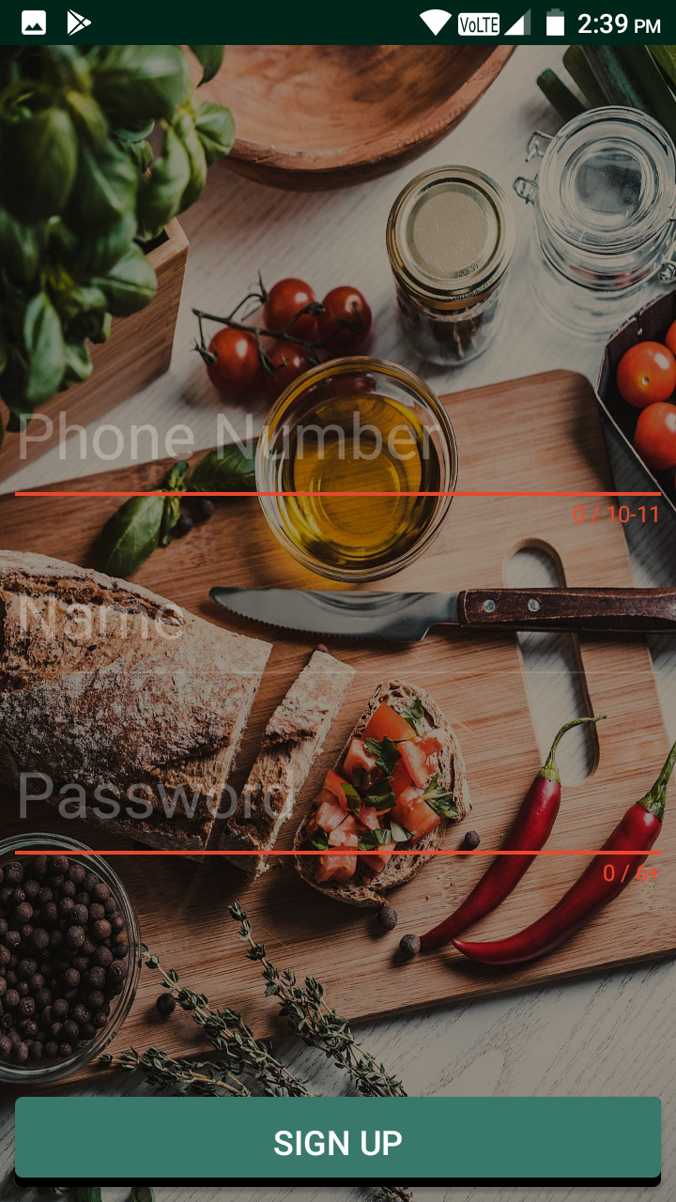

**9.3 Sign In Sign Up successfully**

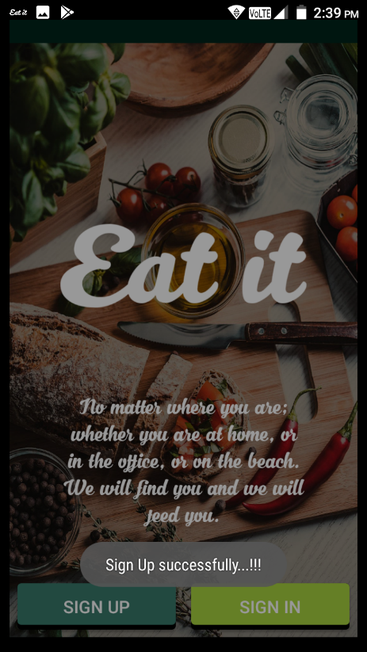

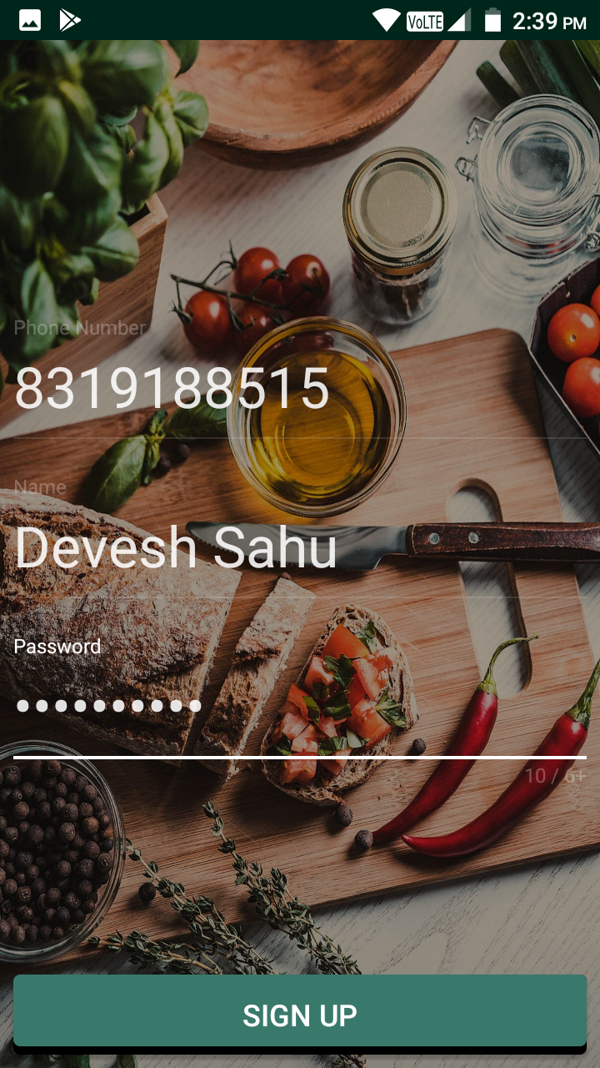

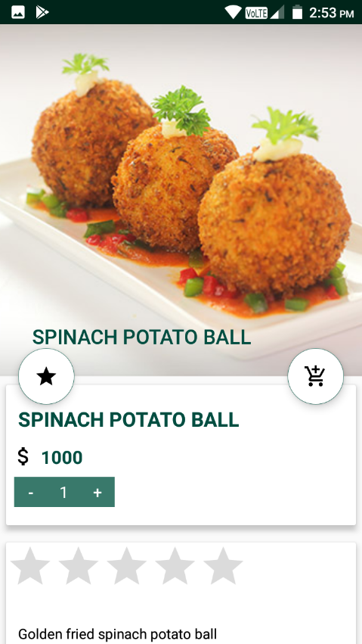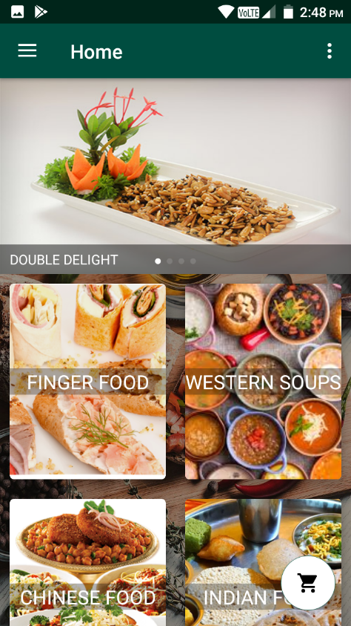**9.4 Home Activity after clicking on banner**

**9.5 on scrolling 9.6 clickingon**

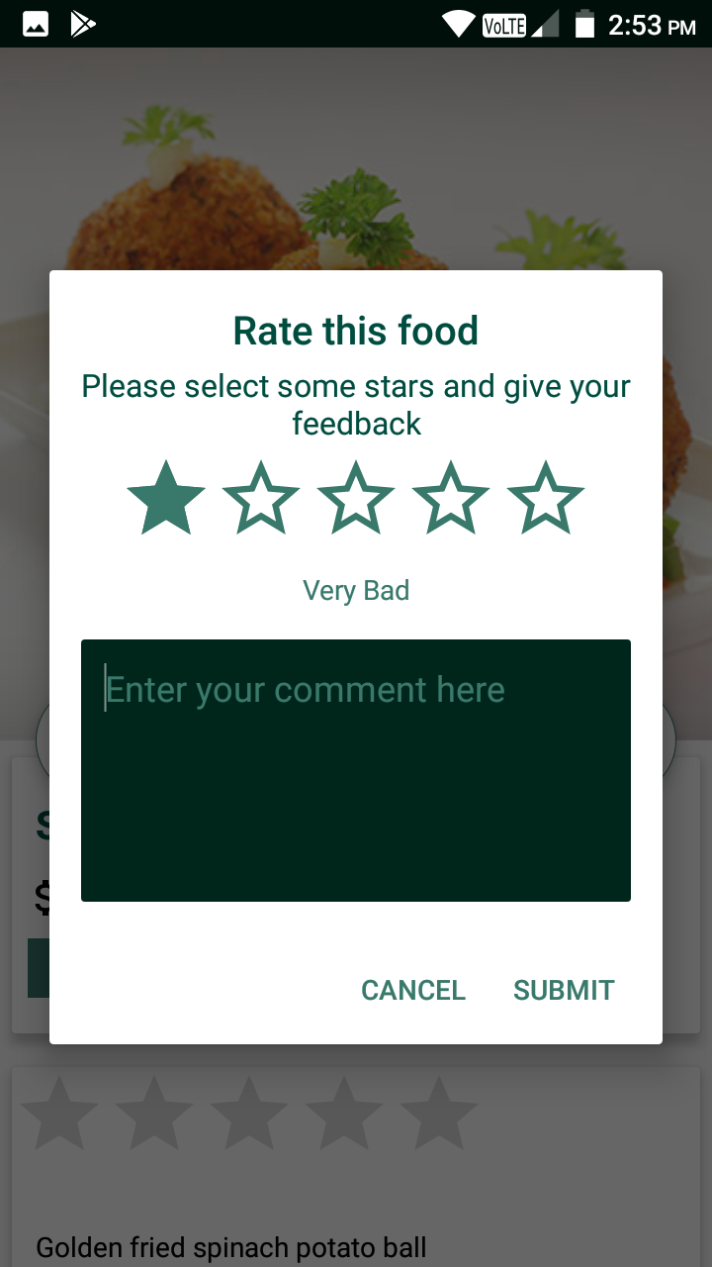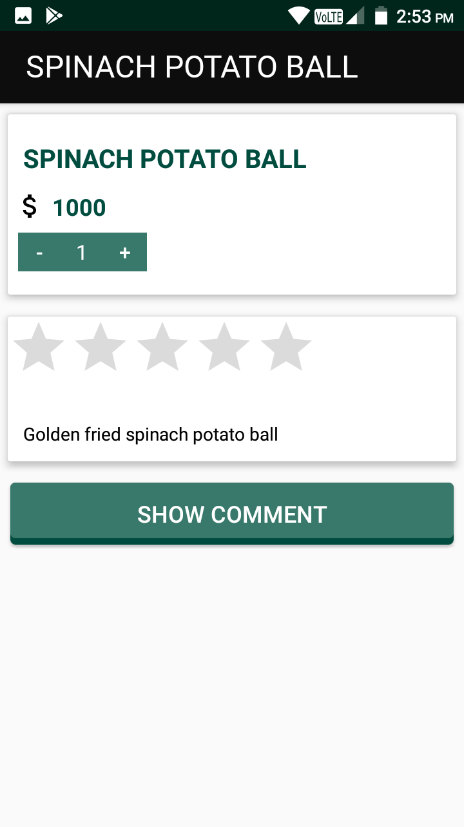

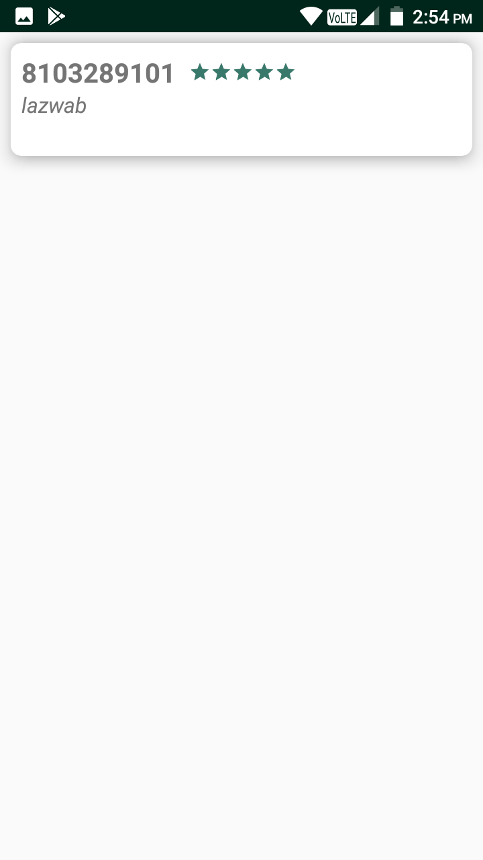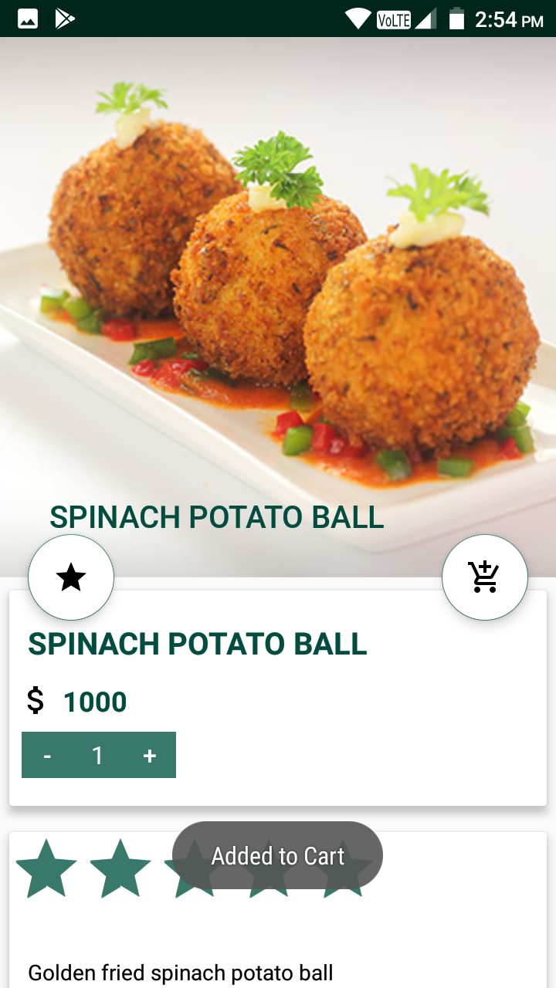**9.7 clicking on cart button 9.8 click on show comment button**

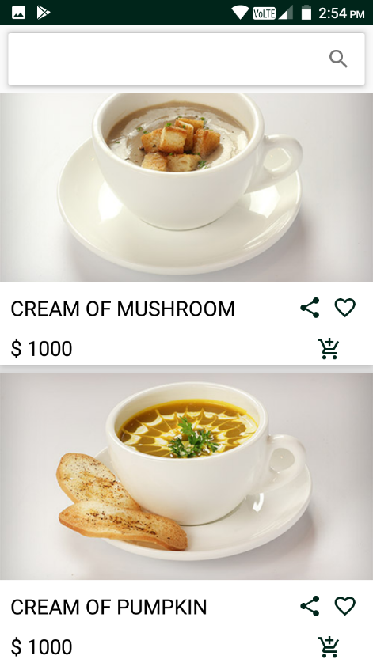**9.9 form home we click on any category then**

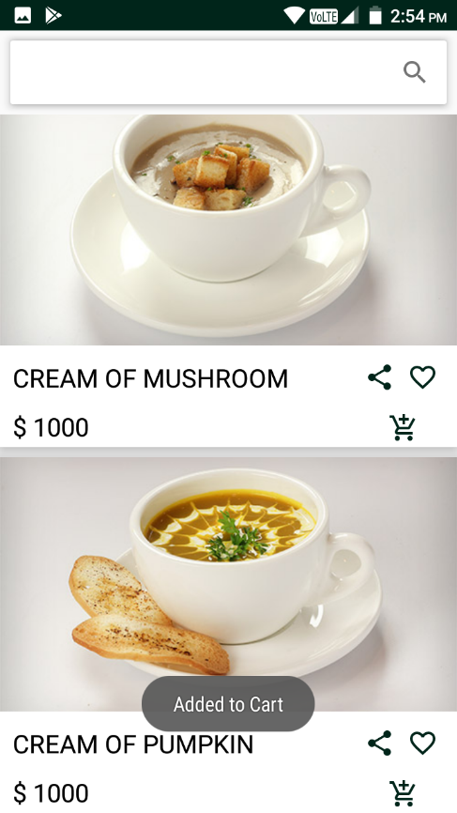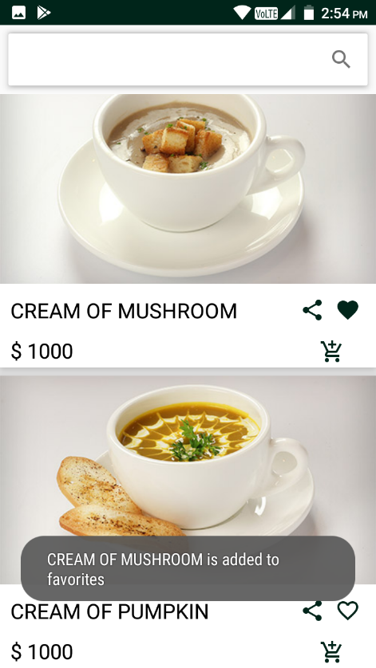**9.10 clicking on cart button 9.11 we can add or remove from favorite**

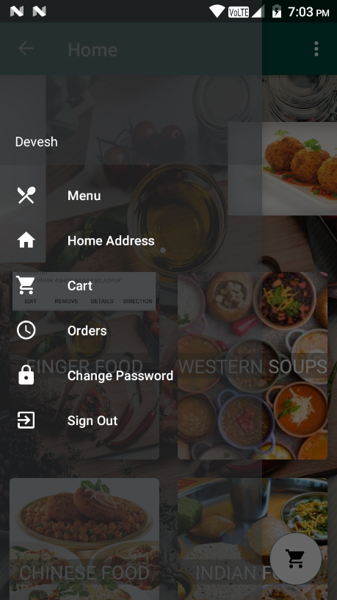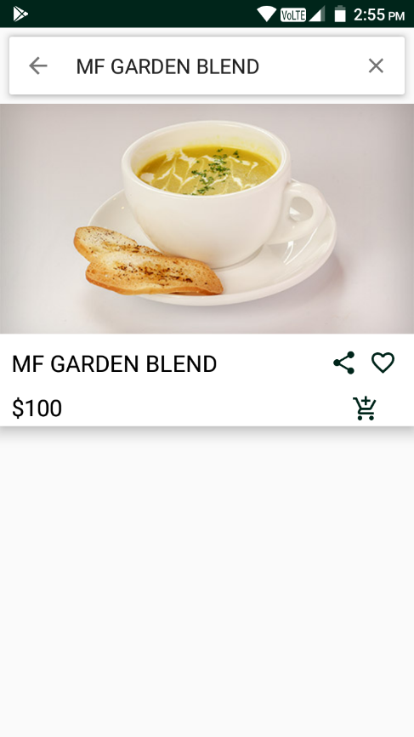**9.12 Search box 9.13 Navigation Drawer**

**9.13 Home address 9.14 Cart**

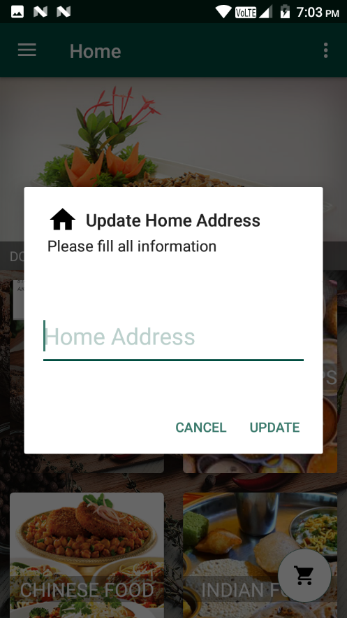 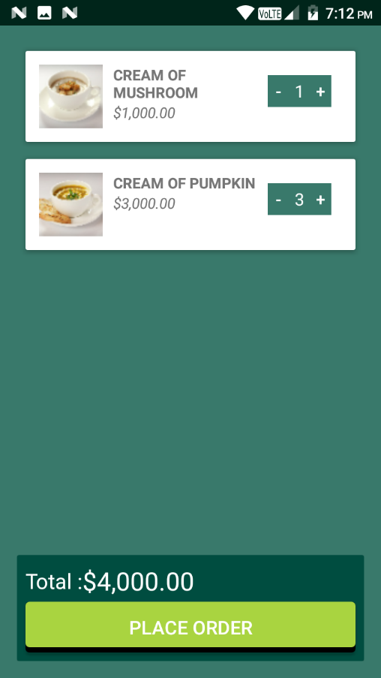

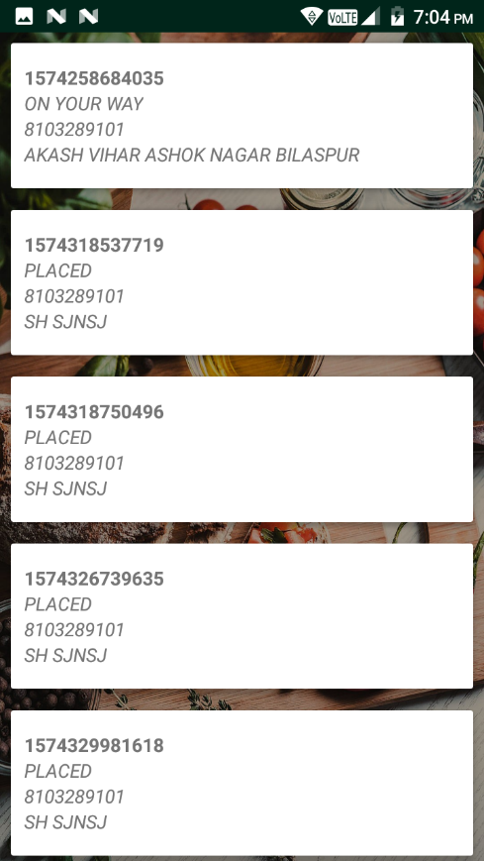**9.15 Orders 9.16 Change Password**

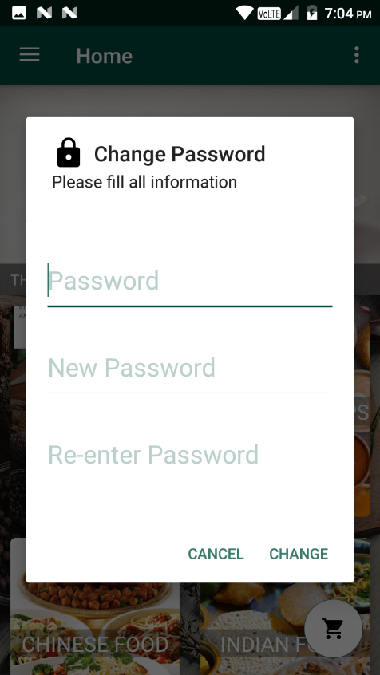

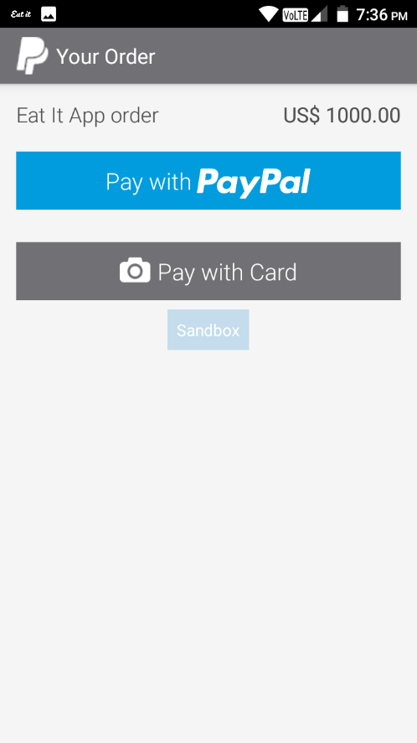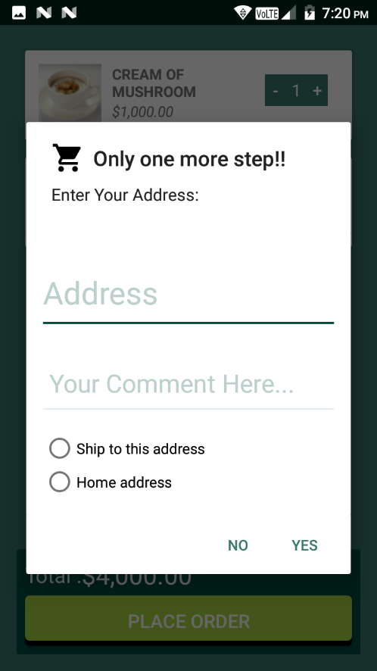**9.17 after clicking on place order 9.18 fill out form & tap to YES then**

**Payment gateway come fill necessary requirements then checkout**

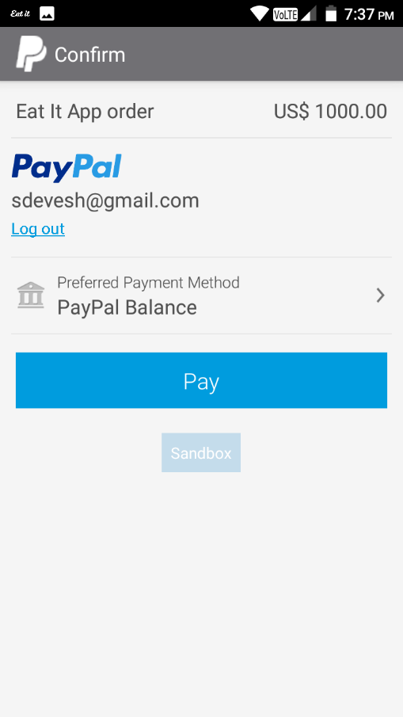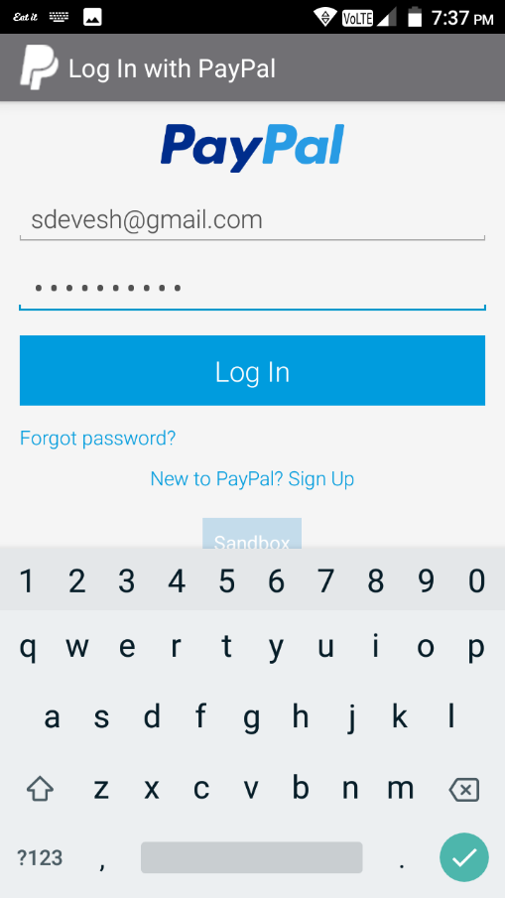

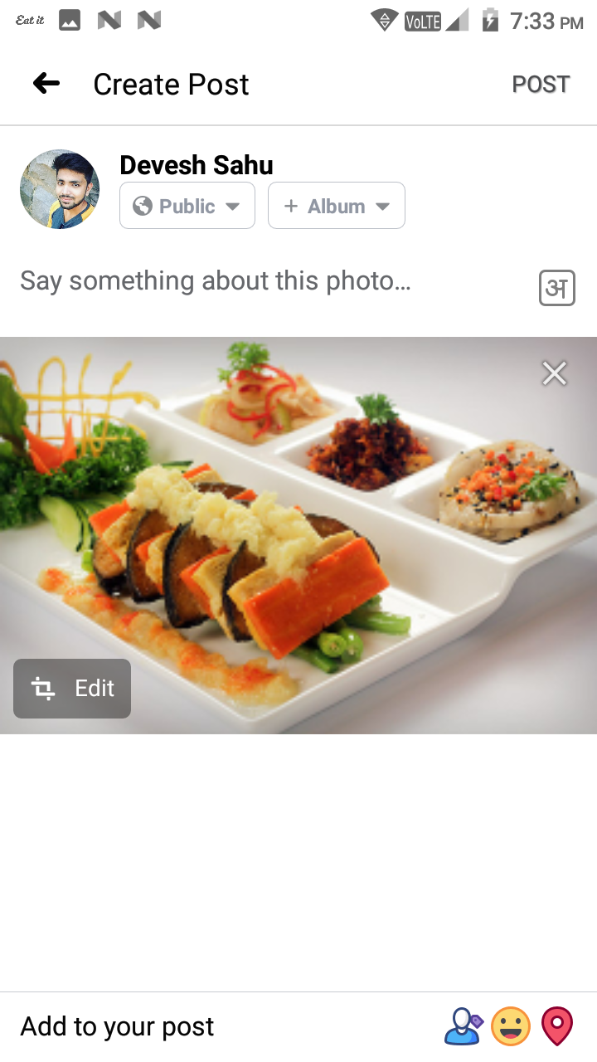**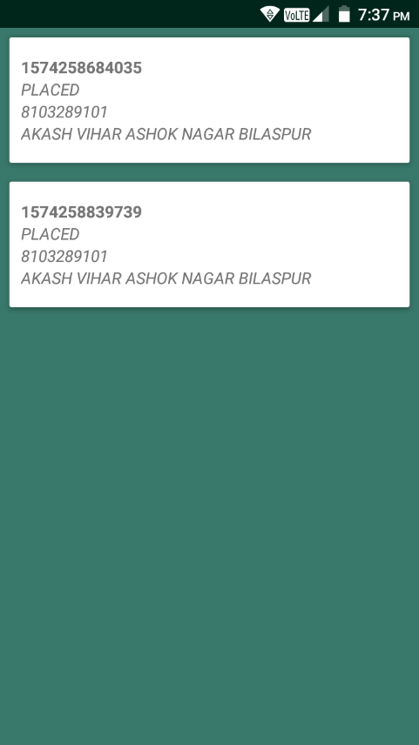9.19 Order Status 9.20 we can share post to facebook**

**9.21 Server App welcome 9.22 login**

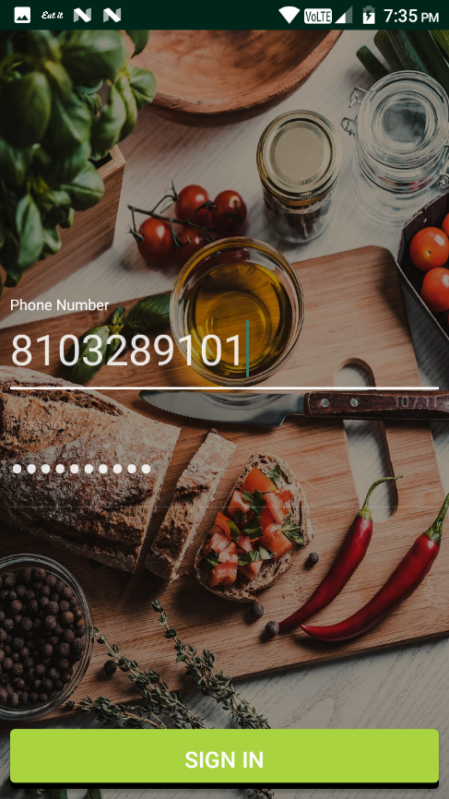

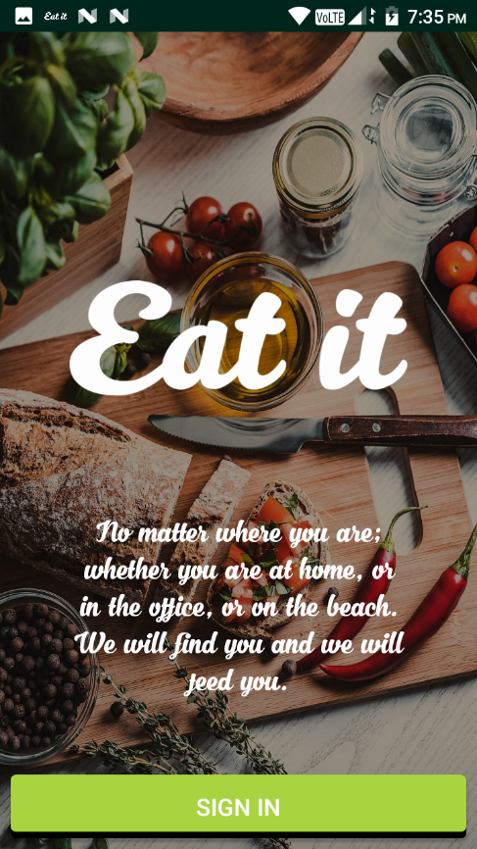

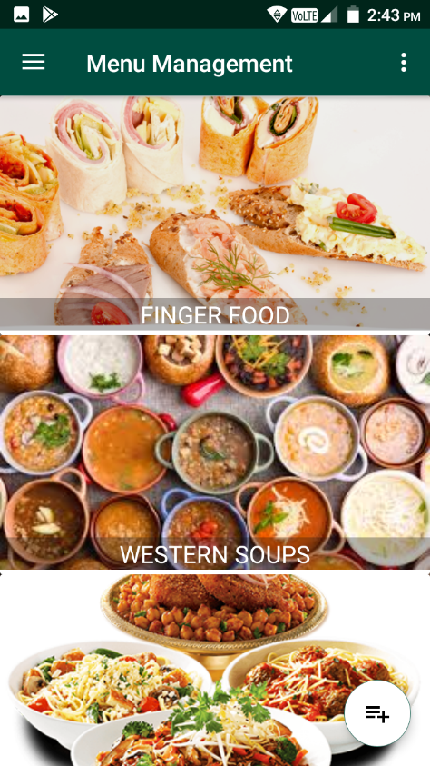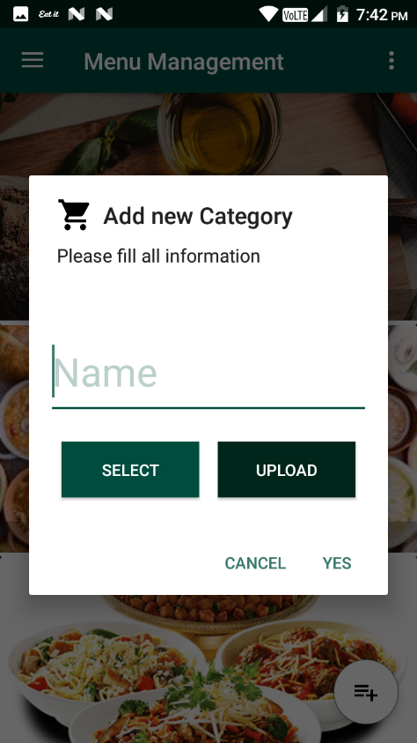**9.23 Home 9.24 Add Category**

**9.25 Update Category 9.26 upload image**

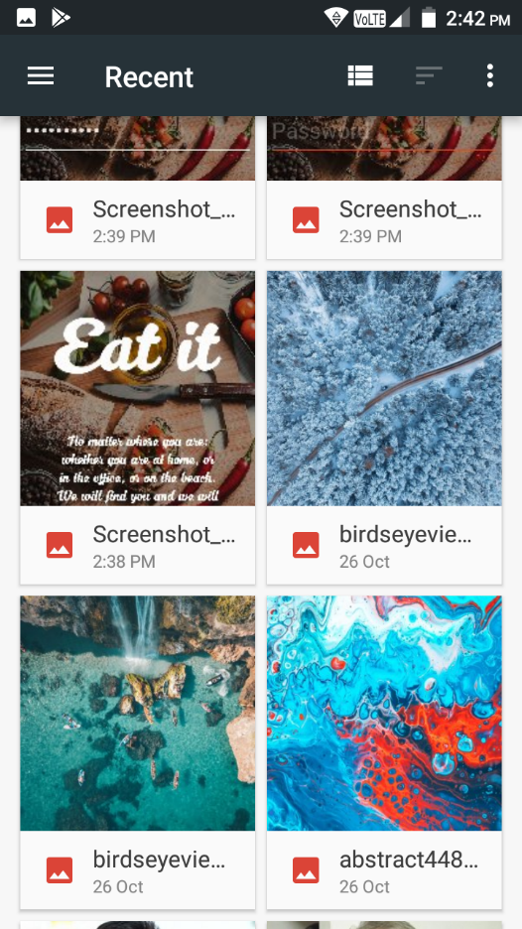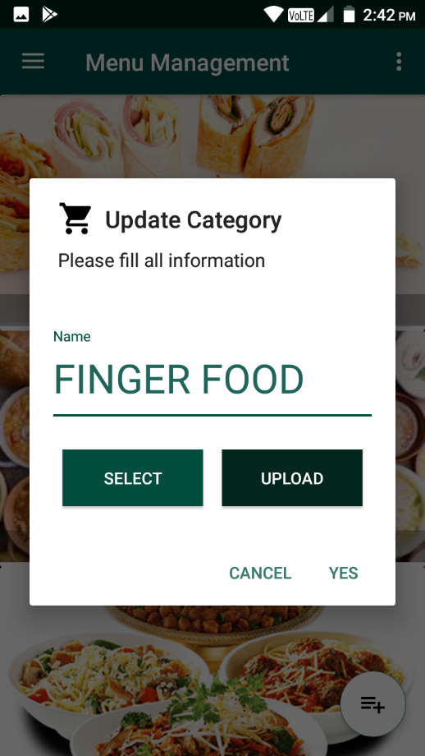

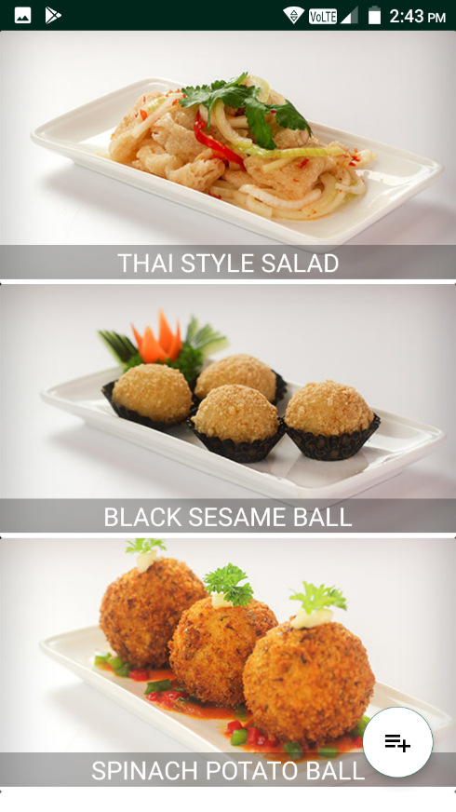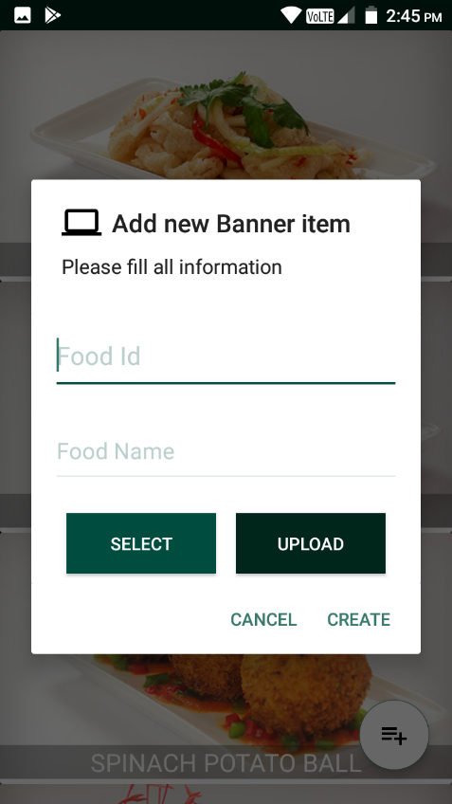**9.27 Banner Management 9.28 Add banner**

**9.30 Update Banner 9.31 Delete banner**

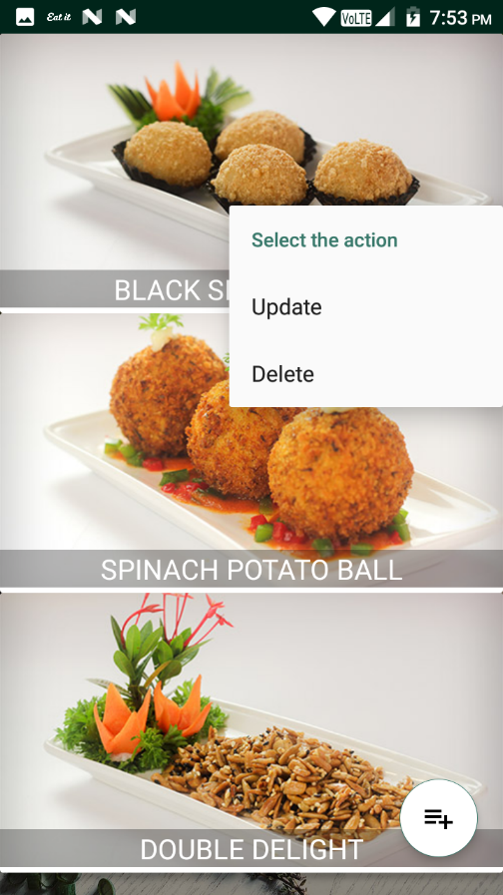

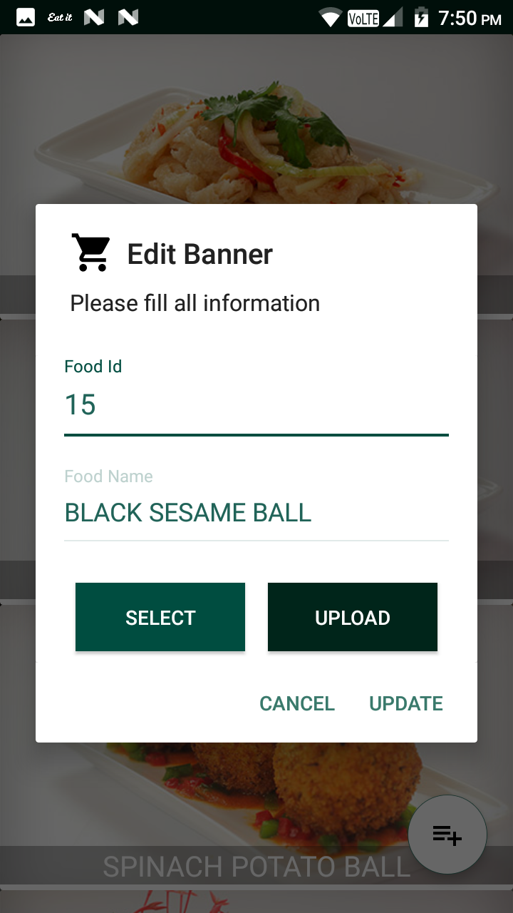

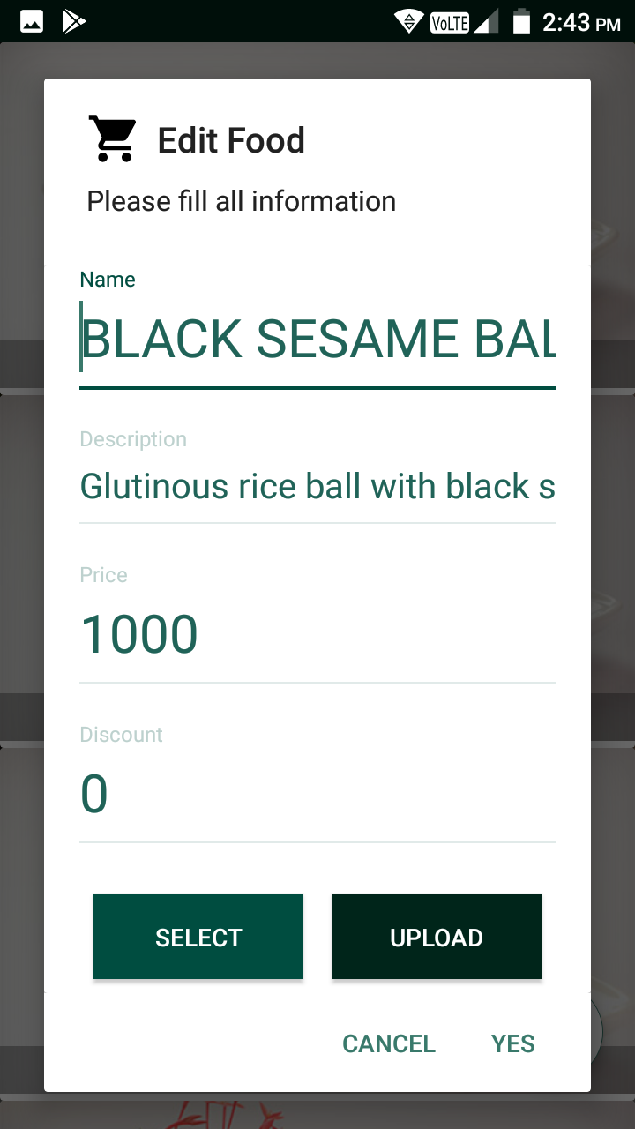**9.32 Add food item 9.33 Update Food item**

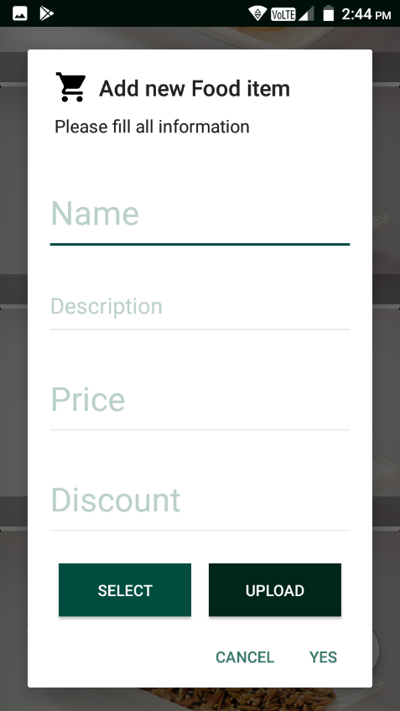

**9.34 Delete Food item 9.35 Menu**

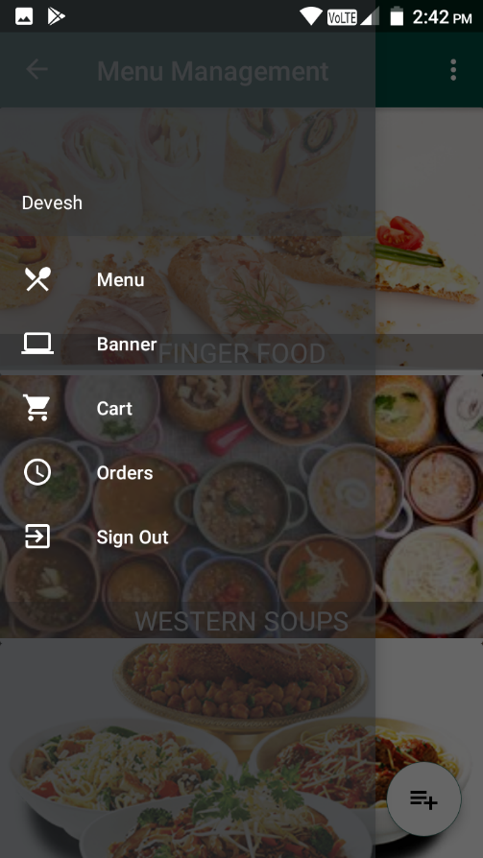

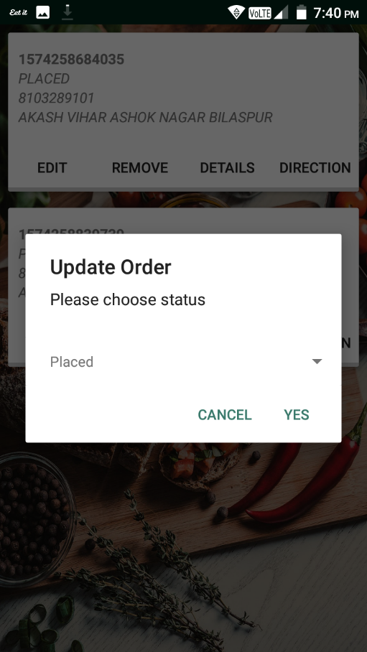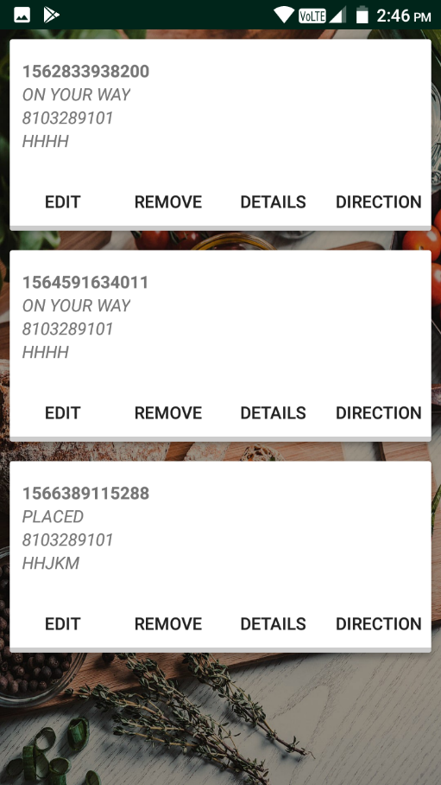**9.36 Orders 9.37 Edit**

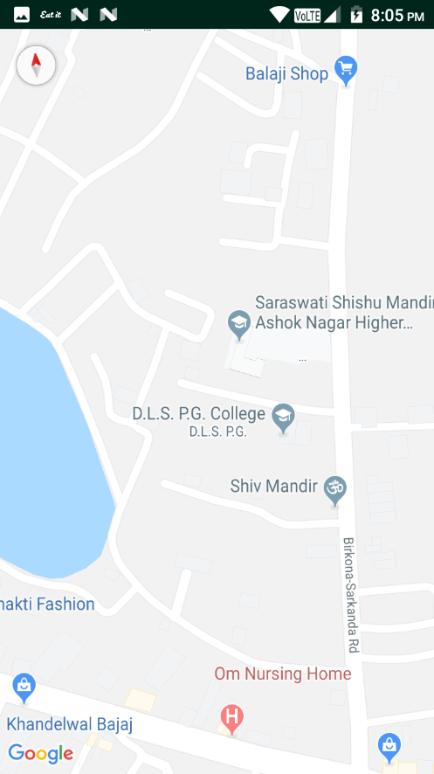**9.38 Details 9.39 Direction**

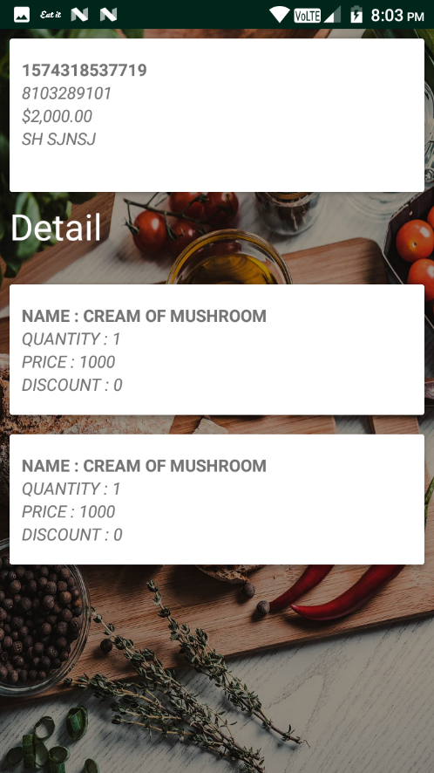

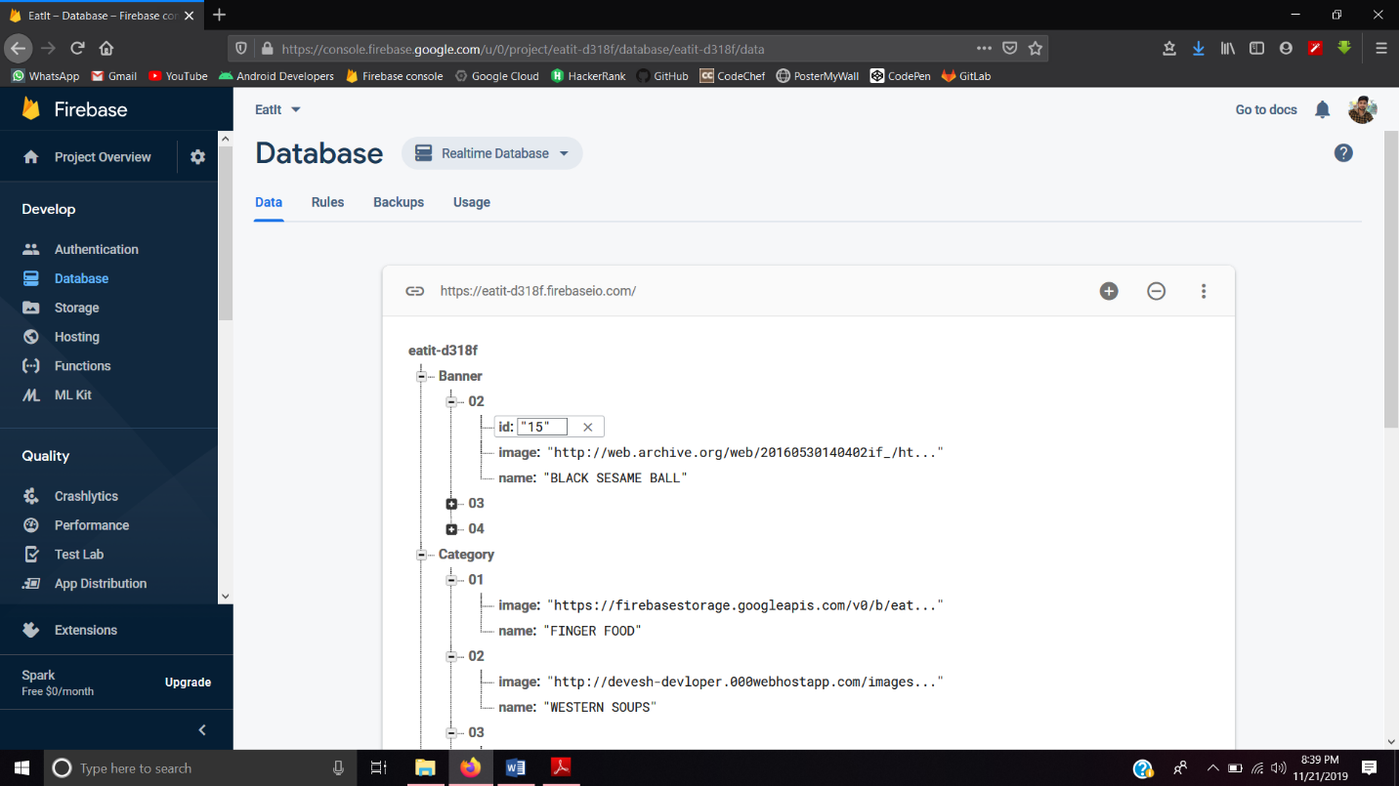**9.40 Firebase Realtime database**

**9.41 Firebase Storage**

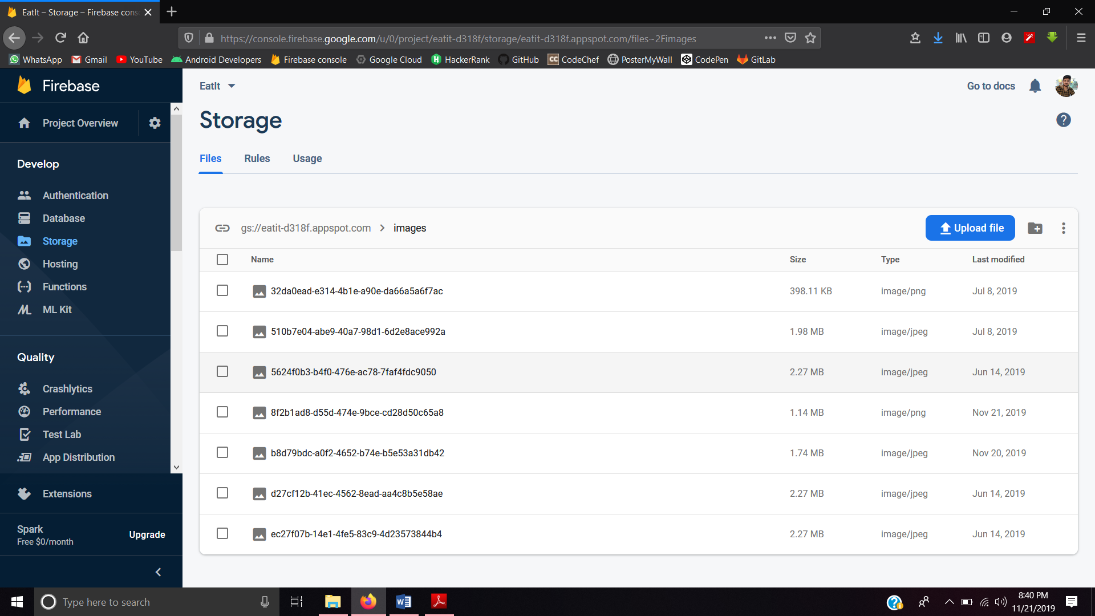

**10. CONCLUSION:**

In this, we planned the automated food ordering system for the restaurant. The system is compared to earlier food ordering traditional methods such as traditional pen and paper methods etc. We have deliberated advantages of the proposed system over those earlier methods. The segregating factor for the proposed methodology is its adjustable efficiency which comes from the technology it uses.

1. It allow users to browse through different product categories.

2. This is accomplished through an easy to use graphical interface menu options.

3. It allow users to save items to the ordered list and view detailed information about the order.

4. The users can add any number of items to the ordered list from any of the available food categories by simply clicking the Add to Order button for each item. Once an item is added to the ordered list, the user is presented with detailed order to review or continue.

5. It allow the user to Proceed-To-Checkout.

6. It allow the user to track the delivery.

7. This is achieved when a user selects “Proceed to Checkout” button and fill up the Payment material details.

8. It allow the user to see notification message after placing an order.

**11.FUTURE ASPECTS OF PROJECT:**

* Increases the habit to use this Application from home to get food just by performing few actions.
* Improve the UI & UX.
* Live tracking.
* Shipper App must be made.
* Sometime user don’t get notification fix this issue.
* Enhance the security methods.
* Normalization of database table to improve database structure & easily retrieval of user data.

**12.BIBLIOGRAPHY**

<https://developer.android.com/guide>

<https://www.geeksforgeeks.org>

<https://www.tutorialspoint.com>

<https://github.com/>

<https://console.firebase.google.com/>

<https://console.cloud.google.com/home/dashboard>